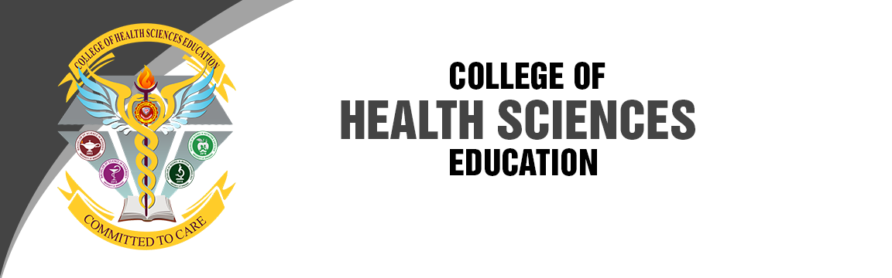

**COLLEGE OBJECTIVES**

1. Offer a curriculum that stimulates intellectual curiosity and develops ability of the students to understand themselves in promotion of health, prevention of illness, collaboration of health care during illness and restoration of health of the individuals, families and community in a changing society.
2. Train effective community leaders and care managers who seek balance in health care resources and contribute to the advancement of the profession.
3. Demonstrate professional values and behaviors and apply theory-based decision making in the delivery of health care services to the individuals, families and community.
4. Provide a state-of-the-art learning landscape that promote excellence, encourages continuous learning and foster pride among the health care providers.
5. Utilize theory and research in formulating evidence-based strategies, initiate changes, improve practices and influence health care policy in the delivery of health care services.
6. Assume a leadership role within the health care delivery system to influence local, regional and national policies that impact on the quality of health care services for the marginalized community.
7. Integrate sensitivity to cultural diversity and the unique characteristics of the individual, the family and the community in the development and implementation of health care services.

UM Nursing Portal